Multimodal Property Valuation: An Integrated Approach Using Tabular Data and Satellite Imagery

Kishore S 24123017

- Introduction and Project Overview

The core objective of this project is to develop and evaluate a multimodal regression pipeline that predicts property market value with greater precision. This pipeline integrates the rich, contextual information available in satellite imagery with standard tabular property features. By combining these two distinct data modalities—structured numerical data and unstructured visual data—the model aims to build a more holistic and accurate representation of a property's true market value.
The methodology follows a systematic, multi-stage approach. The project began with the acquisition and preparation of both tabular and satellite image datasets. This was followed by comprehensive exploratory data analysis (EDA) and the establishment of a robust baseline model using only the tabular data. To extract meaningful information from the satellite images, pre-trained Convolutional Neural Networks (CNNs) were employed for feature extraction. Finally, a series of multimodal models were trained by fusing the image and tabular features, and their performance was systematically compared against the baseline to quantify the value added by the visual data.
This report documents the iterative research journey, from initial methodological explorations to the final comparative analysis, detailing the strategic decisions and experimental outcomes that shaped the final model.

2.0 Initial Research and Strategic Pivot
The first approach attempted was based on Semantic Segmentation. The goal was to train a model to classify each pixel within the satellite imagery into distinct categories, such as 'Building', 'Vegetation', 'Water', and 'Road'. The output would have been a set of quantitative features for each property—for instance, the percentage of the surrounding area covered by green space or the density of buildings. This method, detailed in the initial research notebooks, aimed to translate the visual scene into structured, interpretable data that could be easily appended to the tabular dataset. The dataset contained training images and masks.

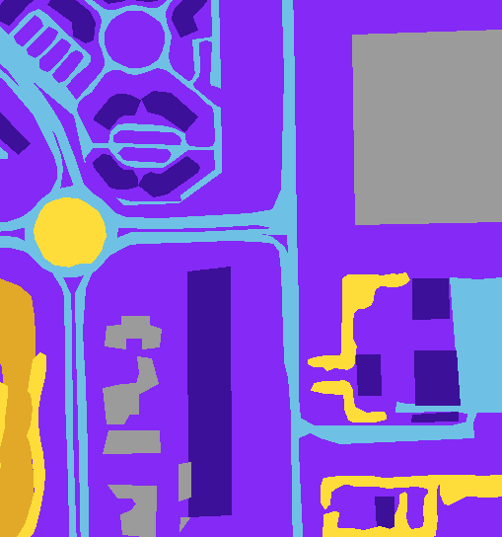
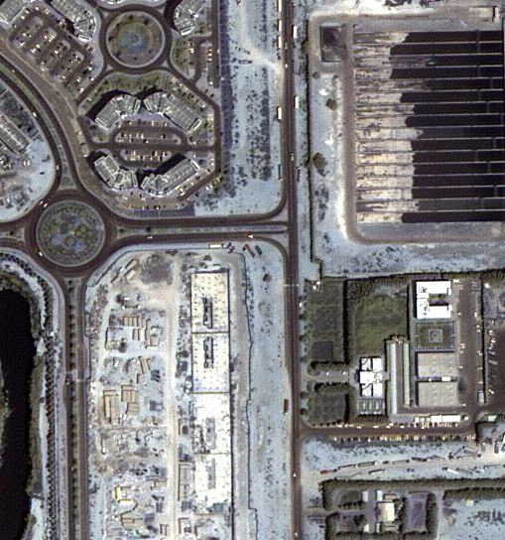

The workflow is given below:
The initial methodology utilized the Semantic Segmentation of Aerial Imagery dataset, processed through a pipeline involving image patchification and normalization. To manage high-resolution imagery, the data was divided into 256x256 pixel patches using the patchify library and scaled between 0 and 1 via the MinMaxScaler. The segmentation masks were converted from RGB hex codes into six categorical integer labels representing classes such as Buildings, Land, Road, and Vegetation. This prepared data served as input for a multi-class U-Net model built with TensorFlow and Keras, which was compiled using the Adam optimizer and monitored via the Jaccard Coefficient (IoU).

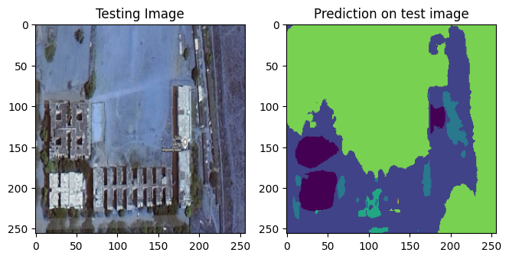

Despite reaching a training accuracy of approximately 89.3%, the model failed to generalize effectively, as the validation IoU plateaued at roughly 69%. The approach was eventually discarded because of dataset inconsistencies and severe class imbalance, which caused the model to heavily favor majority features like Land and Water. A quantitative analysis of test predictions revealed that the model was highly inaccurate for low-frequency categories; for instance, it predicted only 188 pixels for Vegetation when the ground truth required 1,376 pixels. These discrepancies resulted in "fuzzy" boundaries and unreliable segmentations for critical features such as roads and buildings, necessitating a more robust final solution.

Analysis of this initial approach revealed that it did not achieve the desired level of accuracy for this specific application. The project pivoted to using pre-trained Convolutional Neural Networks (CNNs) for transfer learning. This strategy was deemed superior because it excels at capturing abstract, high-level visual patterns—such as architectural textures, spatial arrangements of properties, or qualitative indicators of neighbourhood affluence—that are difficult or impossible to encode with discrete pixel classes. Instead of generating hand-crafted features through segmentation, this revised approach leverages deep learning models, already trained on millions of images, to automatically extract high-dimensional feature embeddings. These embeddings act as a rich, dense summary of the visual content within each satellite image, providing a more effective and direct representation of the visual context.

3. Tabular Data: Exploratory Data Analysis (EDA)

The foundational dataset consists of historical housing data with key features such as price (the target variable), sqft_living, grade (construction quality), and the property's lat (latitude) and long (longitude) coordinates. An initial EDA was conducted to understand the relationships between these features and the property price. The correlation matrix revealed the features most strongly associated with the target variable.

Feature | Correlation with price
sqft_living | 0.700933
grade | 0.668852
sqft_above | 0.602648
sqft_living15 | 0.585251
bathrooms | 0.525487

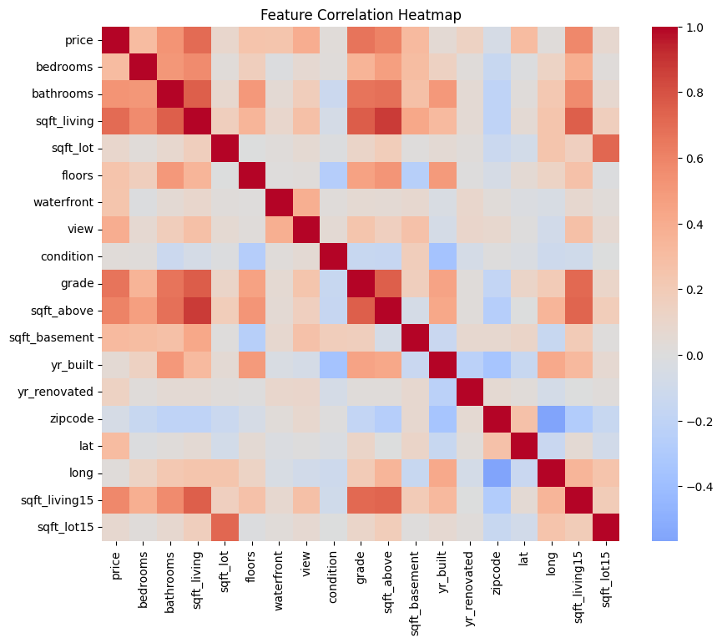
The heatmap visually confirms these findings, showing strong positive correlations between price and features like sqft_living and grade. This analysis guided the feature engineering process, which included several key steps to prepare the data for modeling:
• New Feature Creation: New variables such as basement_ratio and is_renovated were engineered to capture more nuanced property characteristics.
• Log Transformation: To normalize its right-skewed distribution and reduce the influence of outliers, a log transformation was applied to the target variable, price.
• Categorical Binning: To make the feature more robust and interpretable for tree-based models, the numerical grade feature was binned into categorical labels: "Very Poor", "Average", "Good", and "Excellent".
The Analysis made further are mentioned below:

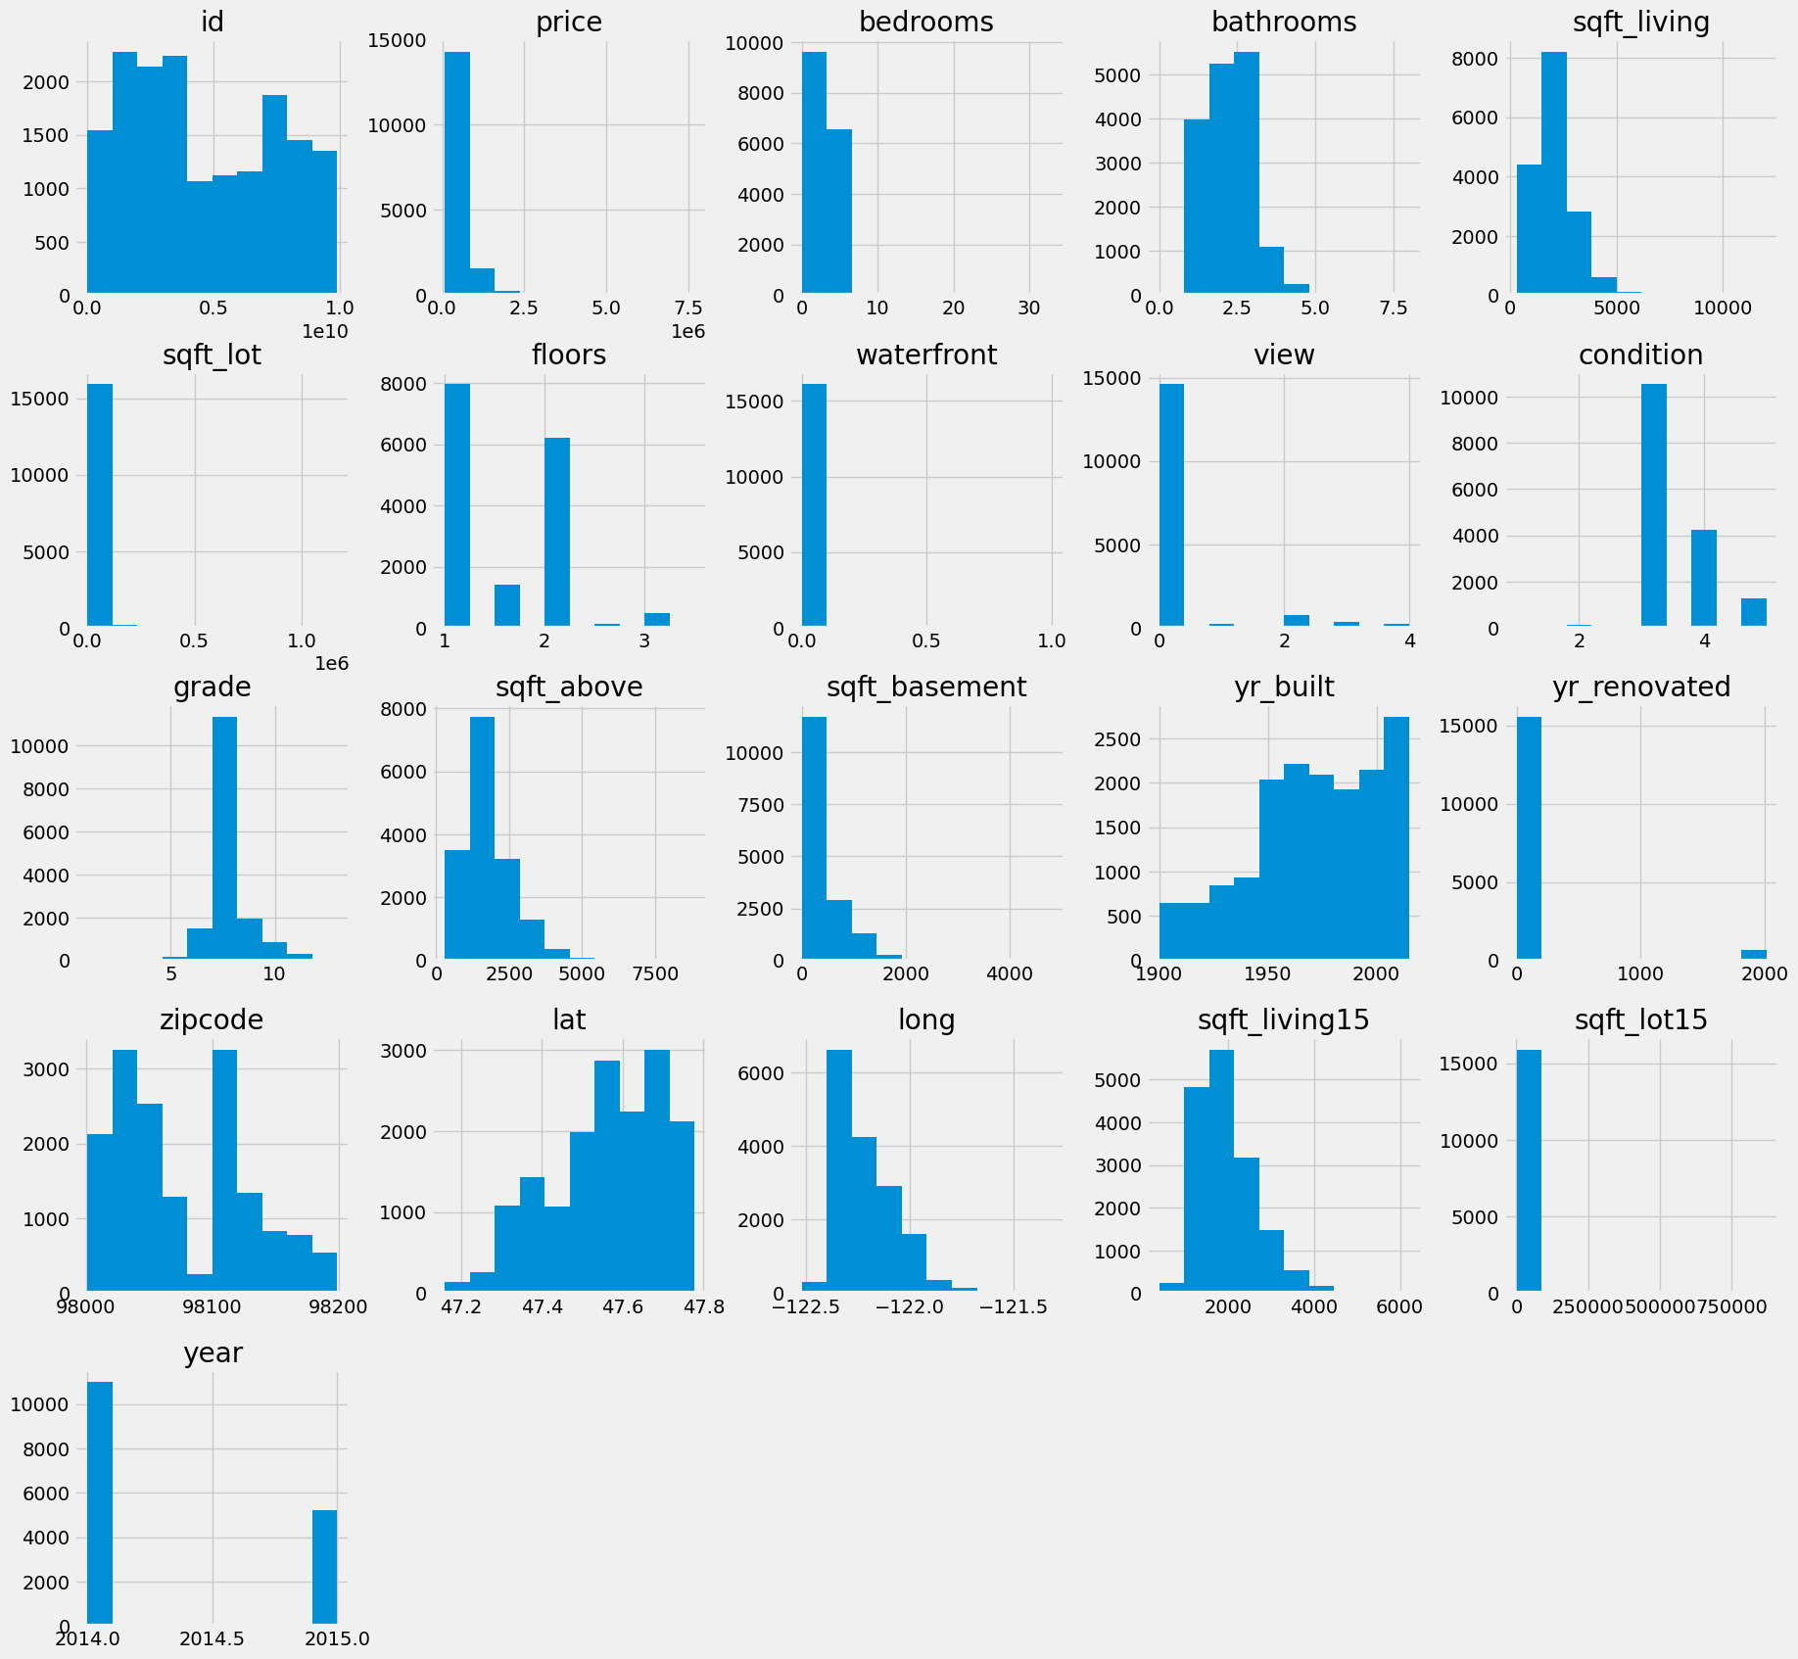

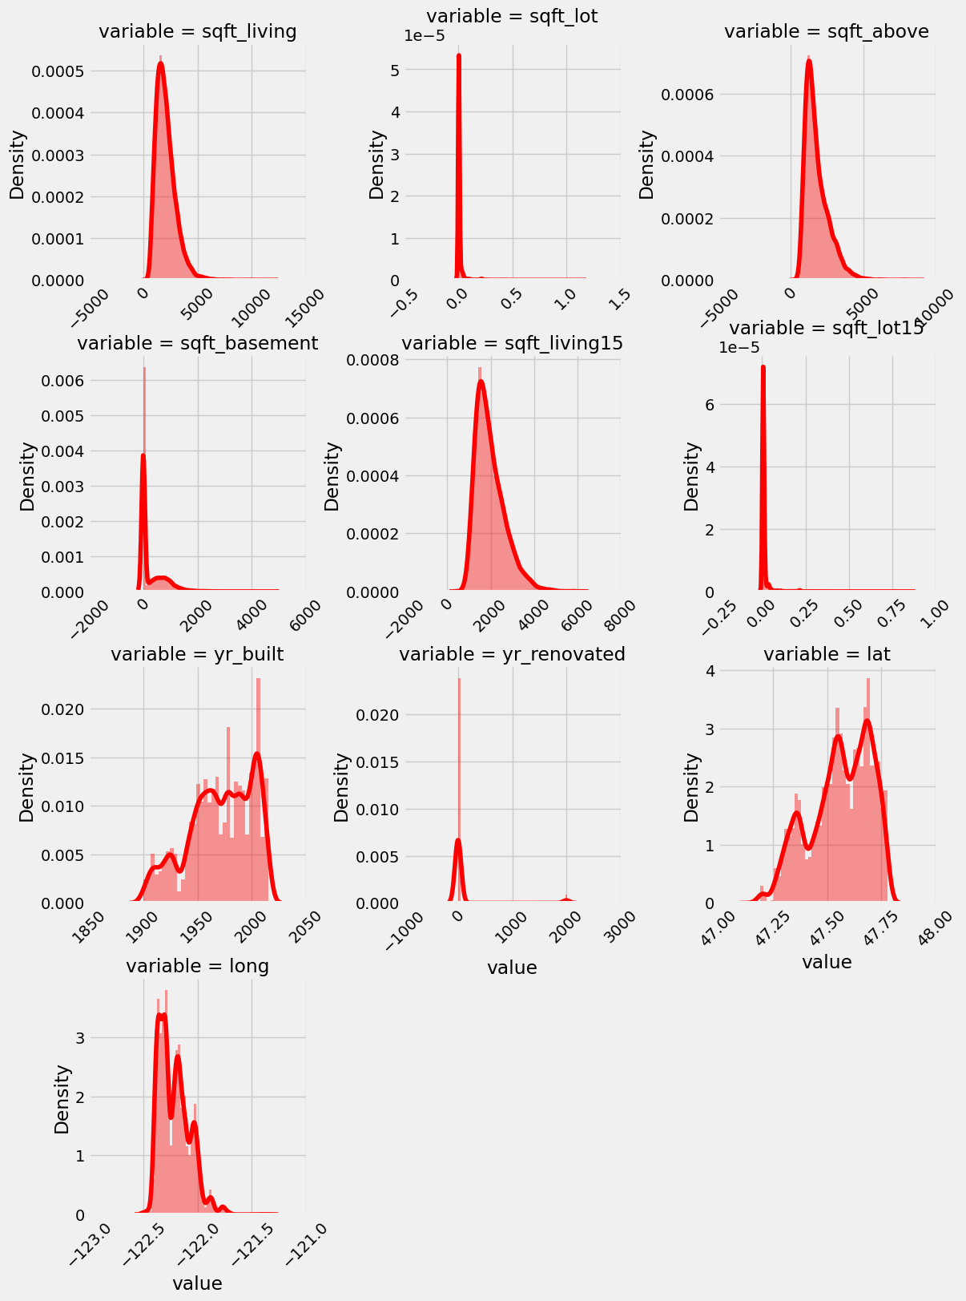

Observations:

- sqft_living, sqft_above, and sqft_living15 are skewed to the right- use log transformation.
- sqft_lot, sqft_lot15, sqft_basement, and yr_renovated have a lot of zero values, maybe create a discrete binary variable for some of them..

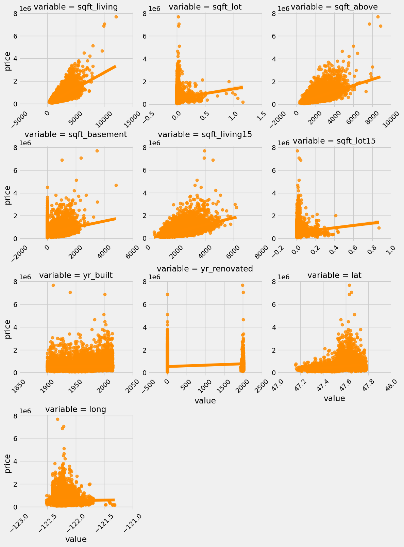
Observations
1. yr renovated should be considered as discrete
2. hard to see relationship of lat, long, and yr_built to price

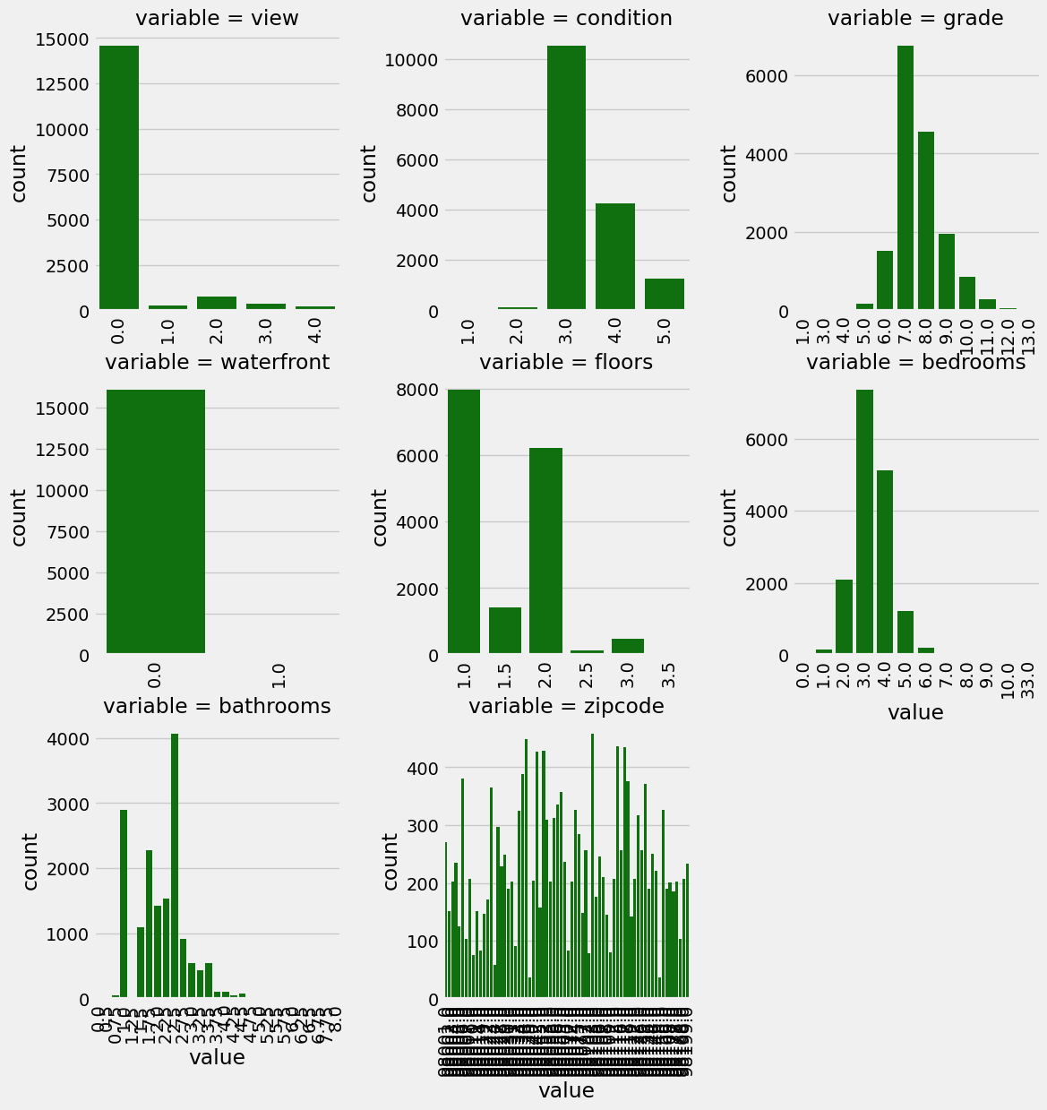
Observations:
- large number of zero values for waterfront
- view bedrooms and bathrooms have right-skewed data
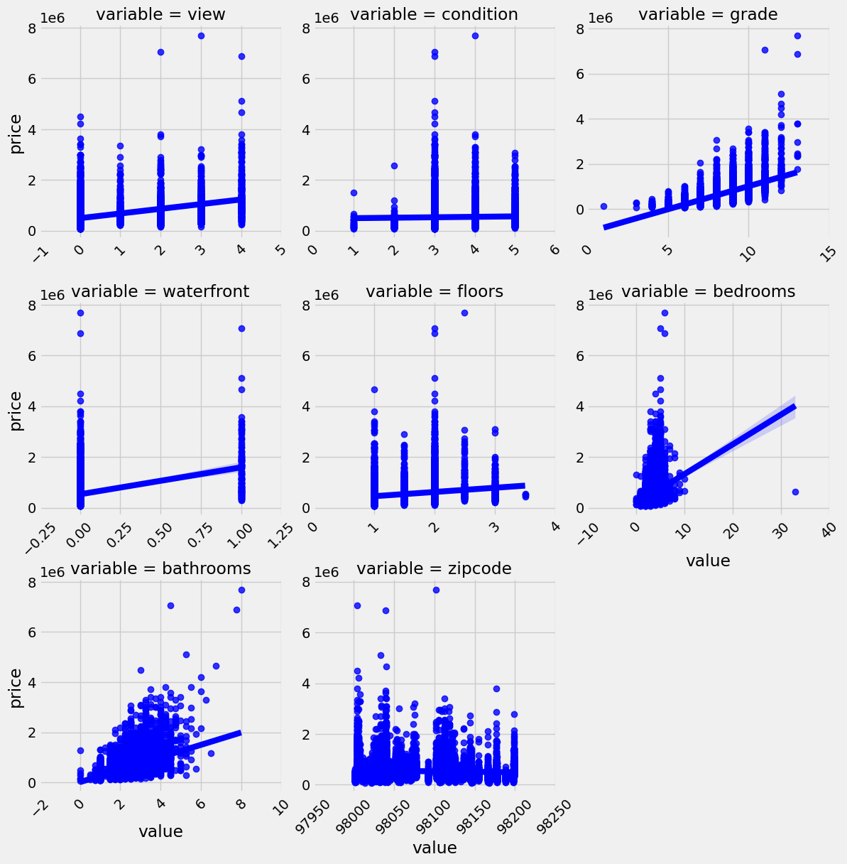

Observations:
1. stronger relationship: bedrooms vs. price, grade vs. price
2. waterfront and view have correlation with price
little relationship between zipcode, condition, and floor

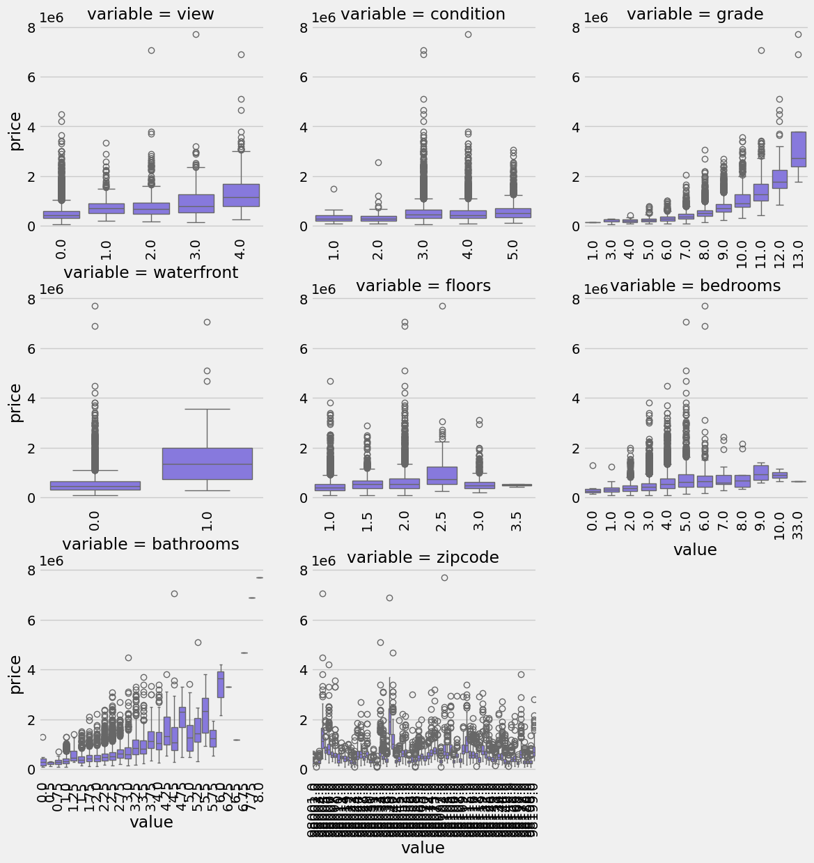

Observations:
1. strong exponential relationship in the mean values for number of bathrooms and grade
2. little correlation with mean views, perhaps express as binary variable
3. potentially replace outliers with the mean for grade and bathrooms

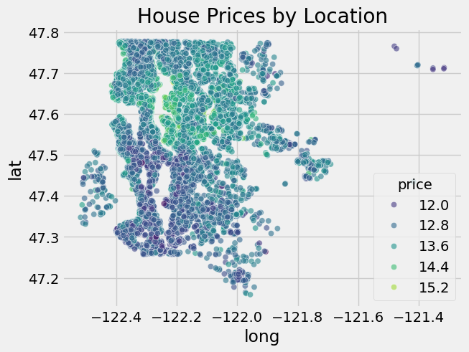

EDA SUMMARY:
- Price is right-skewed → log transformation recommended.
- sqft_living and grade show strongest correlation with price.
- Lot size features are highly skewed → log transform needed.
-Price has a strong correlation with sqft_living and grade
-Price has medium correlation with bedrooms, sqft_above, sqft_living15
-Price has low correlation with bedrooms, floors, sqft_basement, latitude
-Price has no significant relationship with sqft_lot, yr_built, long, sqft_lot15

- Satellite Imagery Acquisition

A significant challenge was to programmatically acquire high-quality, high-resolution satellite imagery for each of the thousands of properties in the dataset using their geographic coordinates. This required a robust and reliable API. A thorough investigation into several potential data sources was conducted to find the optimal solution.

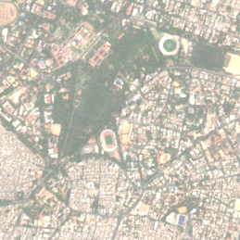
• Sentinel (via Google Earth Engine): An initial attempt was made using the Sentinel-2 dataset through Google Earth Engine, a powerful platform for geospatial analysis.

• Mapbox: The Mapbox Static Images API was also explored as a potential source for high-resolution imagery.

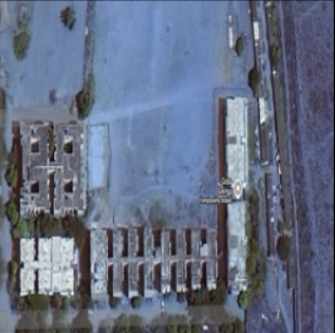
• Sentinel Hub: An attempt to use the Sentinel Hub API was Also made.

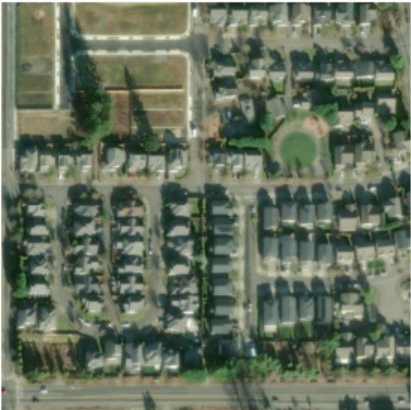
• ESRI ArcGIS: This API proved to be the most reliable and effective solution for this project's needs and was chosen for the final implementation.
The final data acquisition pipeline, built using the ESRI ArcGIS World Imagery API, was designed to capture a comprehensive view of each property and its immediate surroundings. For each set of coordinates, the script fetched a 3x3 grid of image tiles at zoom level 19. These nine tiles were then programmatically stitched together to create a single, larger, and more contextually rich image for every property in the dataset.

- Tabular-Only Model
A suite of standard regression models was tested to identify the best-performing algorithm for this dataset. The models evaluated include Linear Regression, Ridge, Lasso, K-Nearest Neighbors (KNN), Decision Tree, Random Forest, Gradient Boosting, LightGBM, and XGBoost. The results, captured after applying one-hot encoding to categorical features, are summarized below.

Model | RMSE | MAE | R² Score
XGBoost Regressor | 0.167885 | 0.122092 | 0.897353
LightGBM | 0.170445 | 0.122822 | 0.893095
Random Forest | 0.179167 | 0.133018 | 0.880993
Ridge Regression | 0.179167 | 0.133018 | 0.880993
Linear Regression | 0.179169 | 0.133248 | 0.880991
Gradient Boosting | 0.192838 | 0.142227 | 0.864572
Lasso Regression | 0.199340 | 0.133248 | 0.852613
Decision Tree | 0.237540 | 0.171388 | 0.794507
KNN Regressor | 0.236812 | 0.174720 | 0.795765

The XGBoost Regressor emerged as the top-performing tabular-only model, achieving an R² score of 0.897 and a Root Mean Squared Error (RMSE) of 0.168. This result serves as the critical benchmark against which the subsequent multimodal models are compared.

- Multimodal Model with ResNet18 Features

A pre-trained ResNet18 Convolutional Neural Network (CNN) was utilized as a feature extractor. For each satellite image, the CNN processed the visual data and generated a 512-dimensional embedding—a dense numerical vector representing the learned visual features. These 512 image features were then concatenated with the original tabular features, creating a fused dataset.
Model | RMSE | MAE | R² Score
Linear Regression | 222289.298302 | 128547.685669 | 0.757766
Ridge Regression | 222681.914352 | 128585.533852 | 0.756918
Lasso Regression | 222893.306451 | 128548.887989 | 0.756448
Gradient Boosting | 255119.306451 | 119091.872229 | 0.688881
Random Forest | 255420.875806 | 189610.554688 | 0.628130
XGBoost | 258197.876387 | 193988.591142 | 0.625377
KNN Regressor | 356232.963160 | 165045.591598 | 0.377892
Decision Tree | 356232.963160 | 165045.591598 | 0.377892

